Ben
Weekly Relays User Guide
TOPICS LEGEND
 |  | WEEKLY RELAYS |  | June 29, 2017
YOUR DEPARTMENT NEWS |  |  | UTMB NEWS
OCE  Congratulations and thanks to the Office of Clinical Education for hosting a successful Clinical Skills Week!  We are beginning a new academic year with students at our newest site - UT-Tyler Health Science Center.  We have three students starting their Internal Medicine Clerkships in Tyler. We will be adding students from every clerkship as the year proceeds.  OSSA  Dr. Norma Pérez’ article for the CDC is now online in the Journal of Healthcare, Science and the Humanities. Journal of Healthcare, Science and the Humanities.  Commentary: What Does It All Mean? And, So What? Three Main Points To Discuss When Looking at Hispanic Data  OCS  The Office of Clinical Simulation is currently holding the ICEE for all fourth year medical students. It will conclude August 1. |  |  | Annual benefits enrollment begins July 15:  All employees are invited to attend one of UTMB’s Employee Benefits Fairs to learn more about annual enrollment and the insurance, retirement and wellness programs for the 2017–2018 plan year.  - July 11, 10 a.m. – 1 p.m., League City Campus  - July 12, 10 a.m. – 2 p.m., Galveston Campus  - July 13, 10 a.m. – 1 p.m., Angleton Danbury Campus  See iUTMB for details about the fairs and keep an eye out for annual enrollment information from the UT System Office of Employee Benefits and HR’s Benefits Services.  Planned power outage on Galveston Campus:  On July 8 from 7 a.m. to 9 p.m., the third in a series of planned electrical outages will occur. All normal power will be off in McCullough (M11), John Sealy Annex (M9), Old Children’s (M8), JSA-North Addition (M91) and Clinical Sciences (M7) buildings. All affected buildings will be running on emergency power only during this outage. Café on the Court will be closed during this outage.  Reminder—ANCC Magnet recognition program site visit:  Magnet designation is a prestigious recognition that acknowledges excellence in nursing services. On July 10, 11 and 12, three surveyors from the American Nurses Credentialing Center (ANCC) will be on the Galveston Campus and in ambulatory settings to verify and clarify the application information submitted by UTMB. Surveyors will visit patient care and procedural areas. They will want to hear about nursing programs, practices and outcomes; the difference our nurses make at UTMB every day; interprofessional relationships with nursing; and what makes UTMB a great place to work. This survey is limited to the UTMB Galveston Campus.  SAFETY SPOTLIGHT: Do your part for safety—report!  To help identify unsafe conditions and behaviors in the workplace, UTMB’s Environmental Health & Safety team has developed a new online reporting form (https://utmb.us/59). This form encourages the early detection and correction of hazards to our employees, students, patients, visitors and the environment, and it is accessible from any web-enabled device by clicking on the “Report a Concern” button on the Environmental Health & Safety web page (https://www.utmb.edu/ehs). Examples of safety and environmental concerns suitable for reporting include, but are not limited to: slip, trip or fall hazards; unsafe use or disposal of chemicals; and failure to follow safety procedures. Please note that use of this form does not replace the Patient Safety Net system or the requirements under IHOP Policy 9.13.13 Unusual Event Reporting (https://utmb.us/1zz). For questions or assistance with the form, contact William Pate at (409) 772-2270 or wjpate@utmb.edu.
TOPICS  LEGEND | PATIENT CARE EDUCATION & RESEARCH INSTITUTIONAL SUPPORT CMC
AROUND UTMB (Use the legend above to quickly find items of interest to your team)
UTMB NEWS (continued)  Reminder—Town Hall July 6:  Please plan to attend a special midsummer edition of the President’s Town Hall on July 6 at noon in Levin Hall Auditorium. Dr. Callender will discuss the 85th Session of the Texas Legislature and the probable impacts on UTMB. He’ll also give updates on the Best Care initiative, ongoing construction projects across the institution and UTMB’s finances. In keeping with the “just after July 4” theme, Town Hall attendees can enjoy hot dogs, cookies and lemonade following the presentation (available on a first-come, first-serve basis). The Employee Advisory Council will also be in attendance handing out popcorn. For more information and for remote viewing options, visit https://www.utmb.edu/townhall/.  Epic tip of the week:  You can build efficiency into your inpatient Charge Capture flow by maintaining/updating the Problem List. Adding a diagnosis to the Problem List will ensure that the diagnosis is also automatically pulled into Charge Capture, saving you from manually having to update this activity each time you file charges (in other words, you won’t have to insert the diagnosis a second time in Charge Capture). This will help improve cc/mcc capture, as well.  ACTION ITEM: Evaluations deadline:  The deadline for completing all CMC employee evaluations is June 30.  Time card reminder:  All CMC staff must focus on reviewing their time cards to ensure that we do not create off-cycle check requests which result when time cards are approved and processed incorrectly. Please ensure that all staff, timekeepers and managers focus on eliminating the need to create unnecessary off-cycle requests. |  |  | Key Performance Indicators review:  As explained at the recent Town Hall meetings conducted by Dr. Murray, the following metrics will be communicated on a routine basis to help all elements of the CMC enterprise focus on these key performance indicators underscored by our new reimbursement dynamic at Hospital Galveston. As a reminder, our goal is to increase discharges, decrease length of stay (LOS), increase case mix index and decrease off-site admissions. Moving these metrics will enhance efficiency and improve access to care at HG.  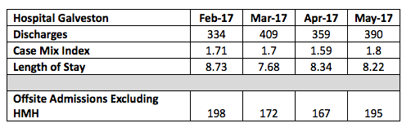
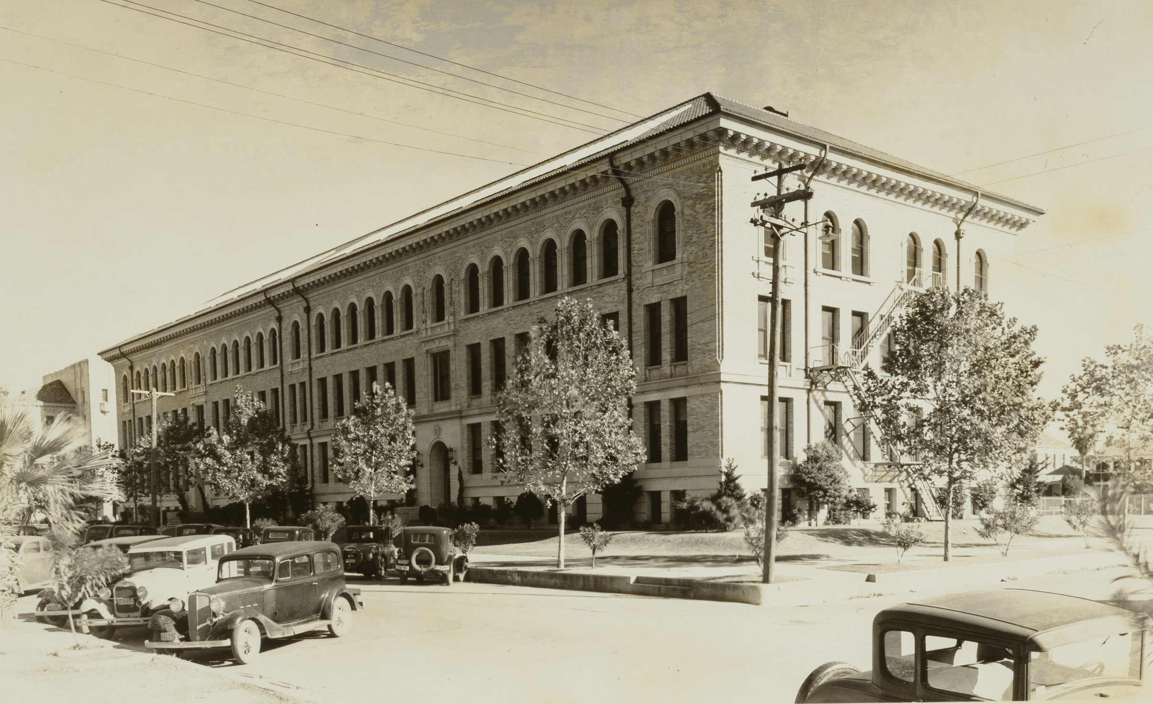
DID YOU KNOW?
The Keiller Building on the Galveston Campus, which opened in 1925 as the Laboratory Building, was the first free-standing structure on the UTMB campus dedicated to the basic sciences. It was renamed for Dr. William Keiller, founding faculty member, anatomy professor, dean and prolific medical illustrator. Today, the historic, state-of-the-art facility is home to the Pathology Department and the Center for Biodefense, critical elements of UTMB’s world-renowned infectious disease programs.

